Modbus Configuration

How to configure a Modbus protocol device according to its Modbus mapping with PecStar?

For example, the Modbus mapping of ION7350 is as below:
Item | Modbus  Address | Parameter | Format | Scale | Range
1 | 40011 | Ia | Singed 32-bit | 100 | -21474836 to 21474836
2 | 40013 | Ib | Singed 32-bit | 100 | -21474836 to 21474836
3 | 40015 | Ic | Singed 32-bit | 100 | -21474836 to 21474836
4 | 40017 | Vab | Singed 32-bit | 100 | -21474836 to 21474836
5 | 40019 | Vbc | Singed 32-bit | 100 | -21474836 to 21474836
6 | 40021 | Vca | Singed 32-bit | 100 | -21474836 to 21474836
7 | 40023 | kW total | Singed 32-bit | 100 | -21474836 to 21474836
8 | 40025 | kVAR total | Singed 32-bit | 100 | -21474836 to 21474836
9 | 40027 | Freq | Singed 32-bit | 100 | -21474836 to 21474836
10 | 40029 | PF sign total | Singed 32-bit | 100 | -21474836 to 21474836
11 | 40031 | kW demand del | Singed 32-bit | 100 | -21474836 to 21474836
12 | 40033 | kVAR demand del | Singed 32-bit | 100 | -21474836 to 21474836
13 | 40035 | kW demand max | Singed 32-bit | 100 | -21474836 to 21474836
14 | 40037 | Ia THD | Singed 32-bit | 100 | -21474836 to 21474836
15 | 40039 | Ib THD | Singed 32-bit | 100 | -21474836 to 21474836
16 | 40041 | Ic THD | Singed 32-bit | 100 | -21474836 to 21474836
17 | 40043 | Va THD | Singed 32-bit | 100 | -21474836 to 21474836
18 | 40045 | Vb THD | Singed 32-bit | 100 | -21474836 to 21474836
19 | 40047 | Vc THD | Singed 32-bit | 100 | -21474836 to 21474836

To read the parameters, please make configurations following the steps:
- Start PecConfig.
- Add a site. Right-click on the Communication Setup folder from the left-hand pane, select New…, and the Site Node Properties window appears. Set the Driver Type to MODBUS-RTU Protocol Master Site Driver. Set the Serial Port parameters to match the port and device.
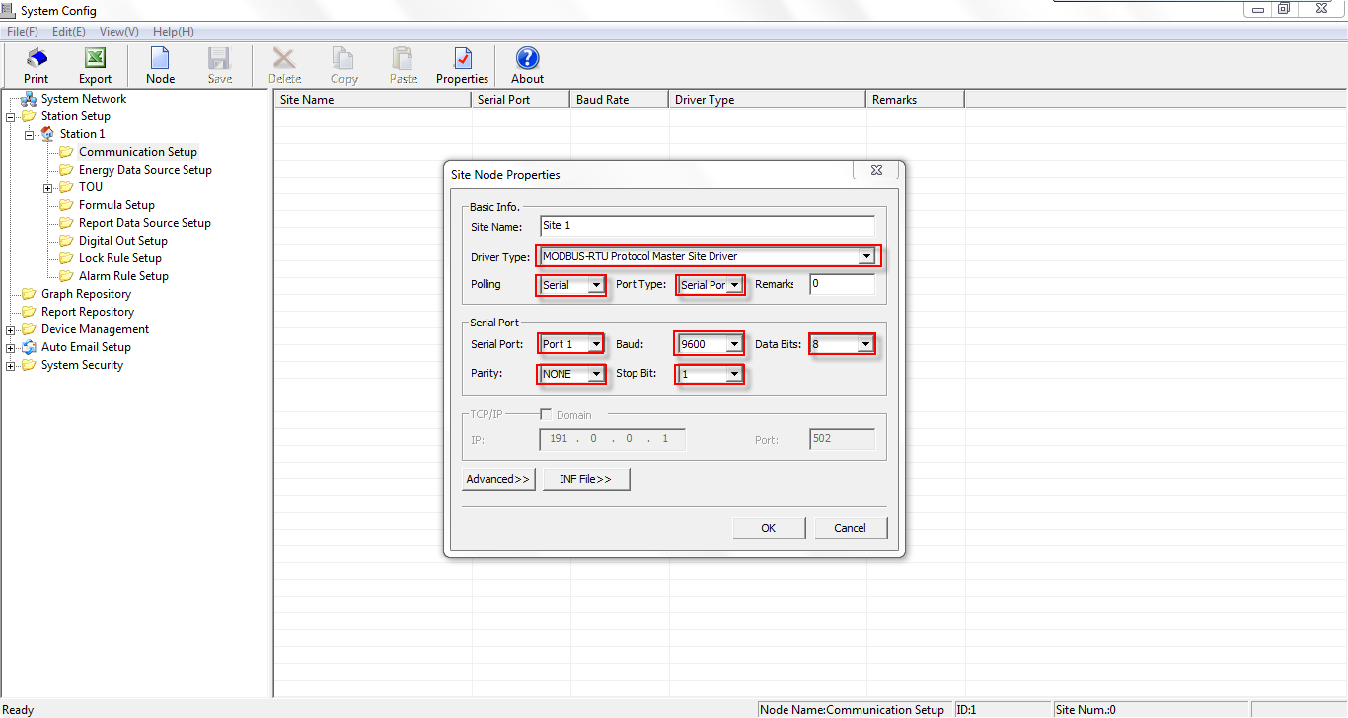
- Add a device. Click + to expand the Communication Setup folder. Right-click on the Site 1, select New…, and the Device Node Properties window appears. Set the Type to ION7350. Set the Comm ID to match the device. Click OK.
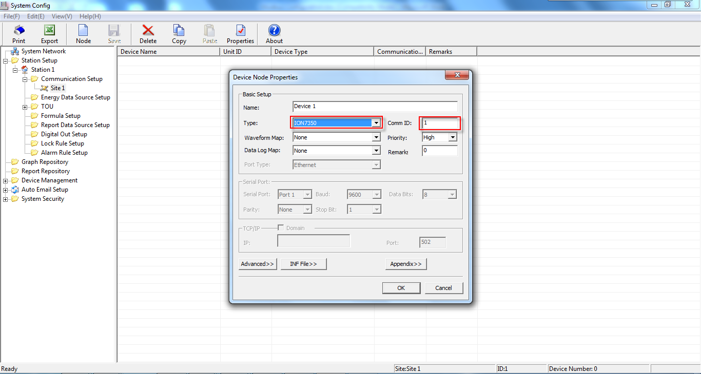
Note: Select a Type from the drop-down list. No need to match the Type to your device.
- Delete all sources. Click on the Device 1, if the sources are imported automatically on the right-hand pane, press Shift to select all, and click Delete from the tool bar.
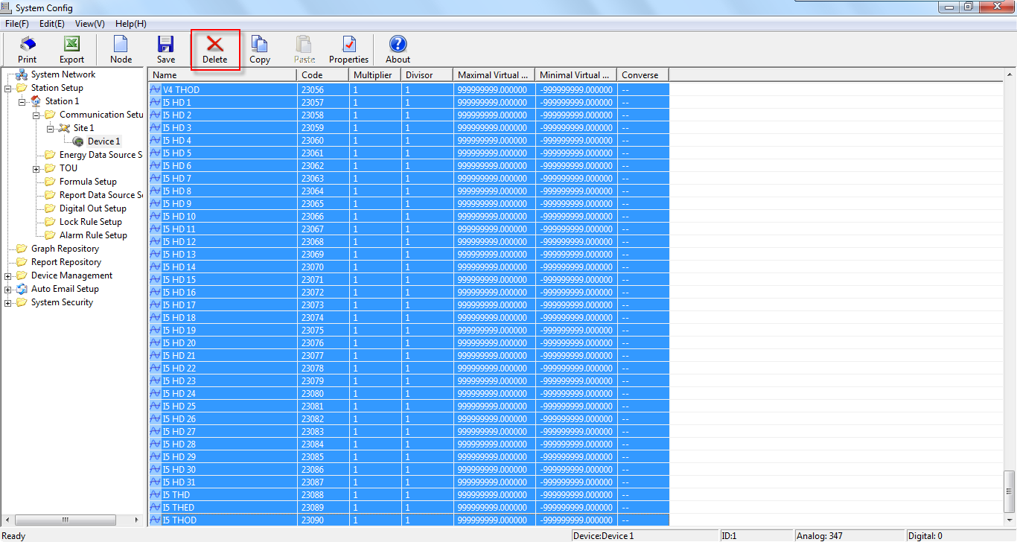
- Add a source. Right-click on the right-hand pane and select New….
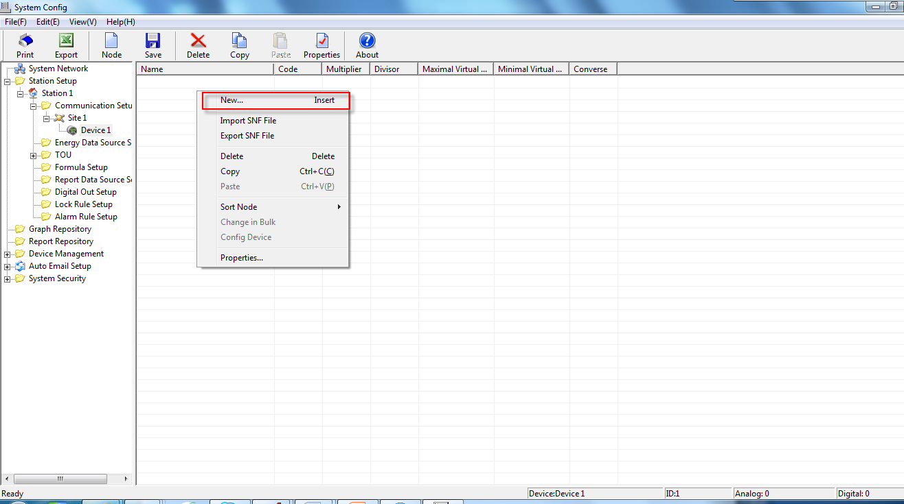
The Select Type of Source window appears. Select Analog and click OK.
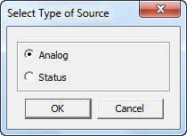
- Edit the Source Properties. The Analog window appears. Enter the Name, Multiplier, Divisor, Max, Min and Add in Bulk.
Name: The name of the parameter.
Multiplier: The scale of the displayed measurements.
Divisor: The scale of the displayed measurements. Because the Scale of ION7350 Modbus register is 100, so enter 100 for the Divisor to reflect the real data.
Max: The maximum value of the parameter.
Min: The minimum value of the parameter.
Add in Bulk: Enter the number of the parameters.
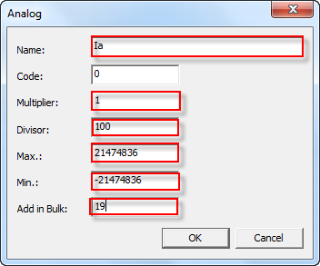
- Edit the source properties.
Press Shift to select all other sources, right-click and select Change in Bulk from the pop-up window.
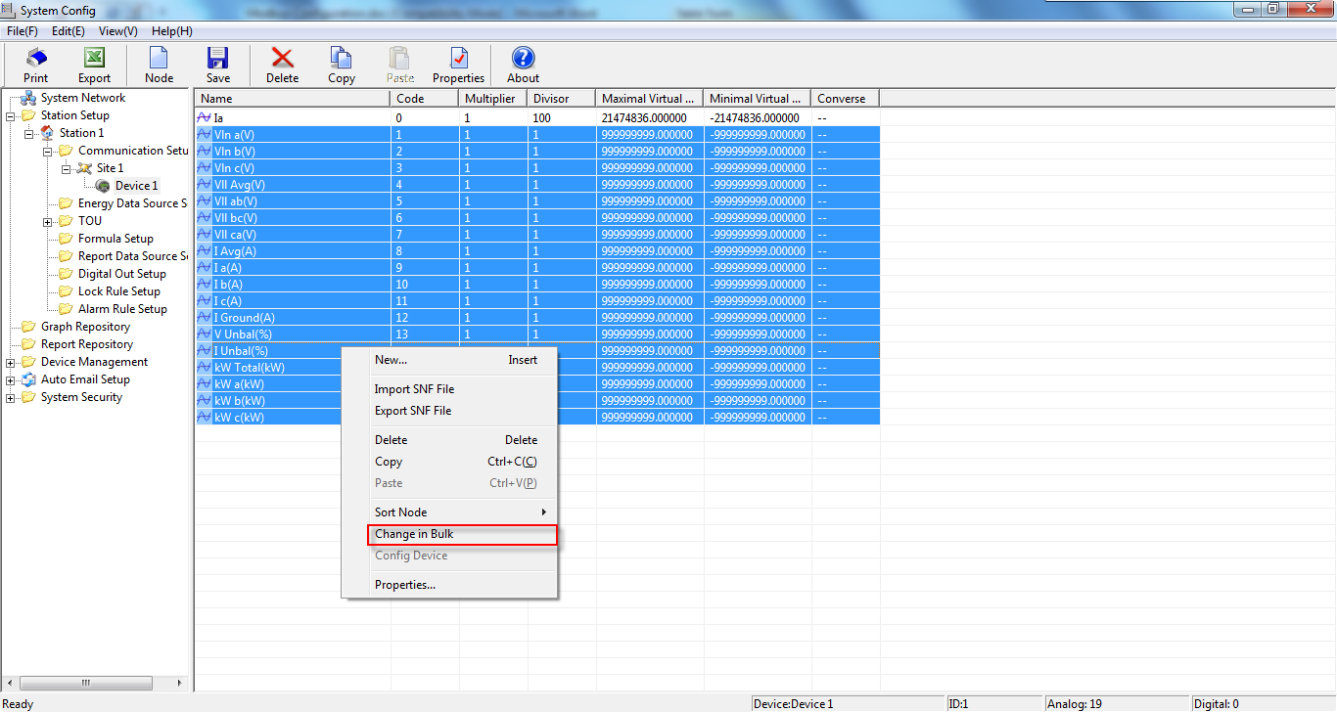
Edit the Divisor, Max, and Min. And click OK.
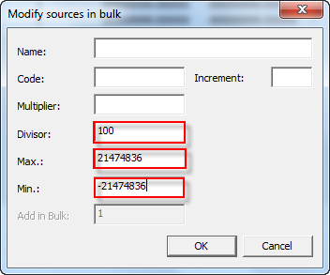
The sources are as below.
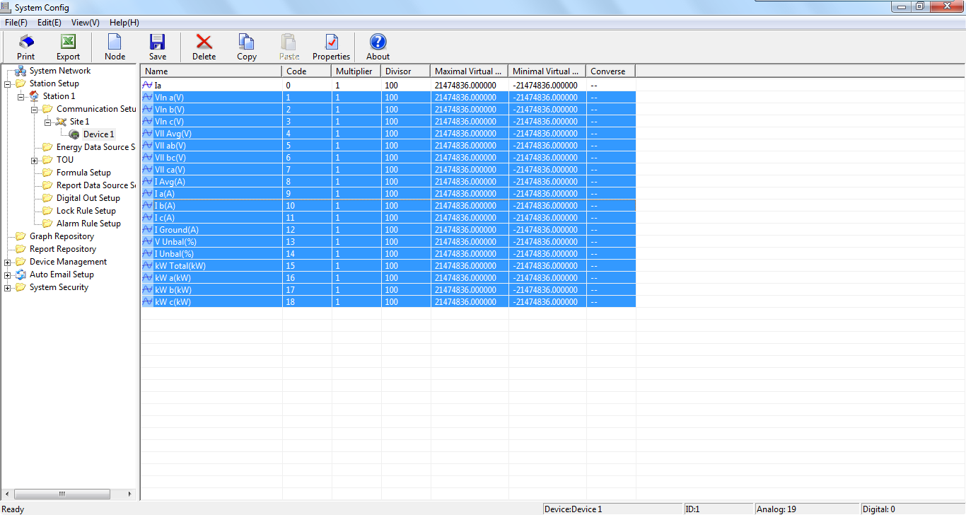
Select the other source and click on the area of the Name column. Enter the Name.
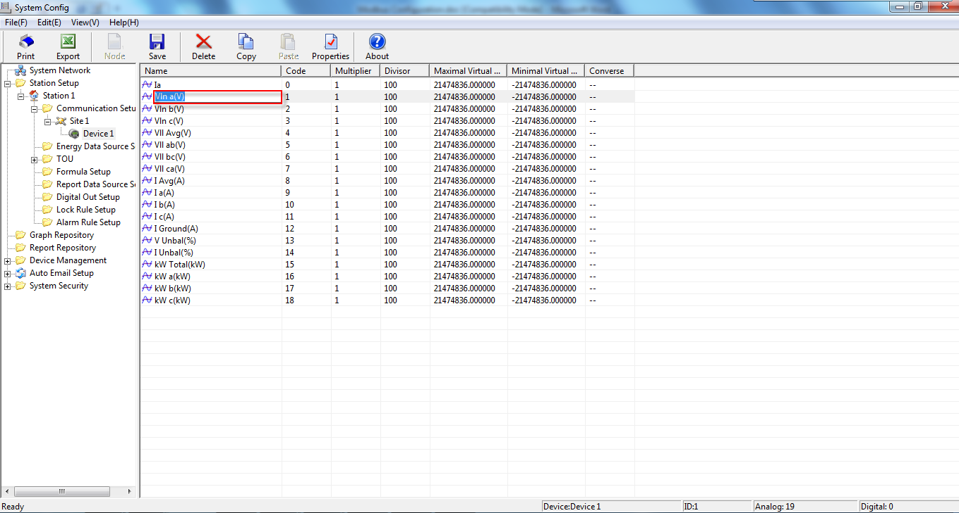
When all parameters are edited, as below. Click Save from the tool bar.
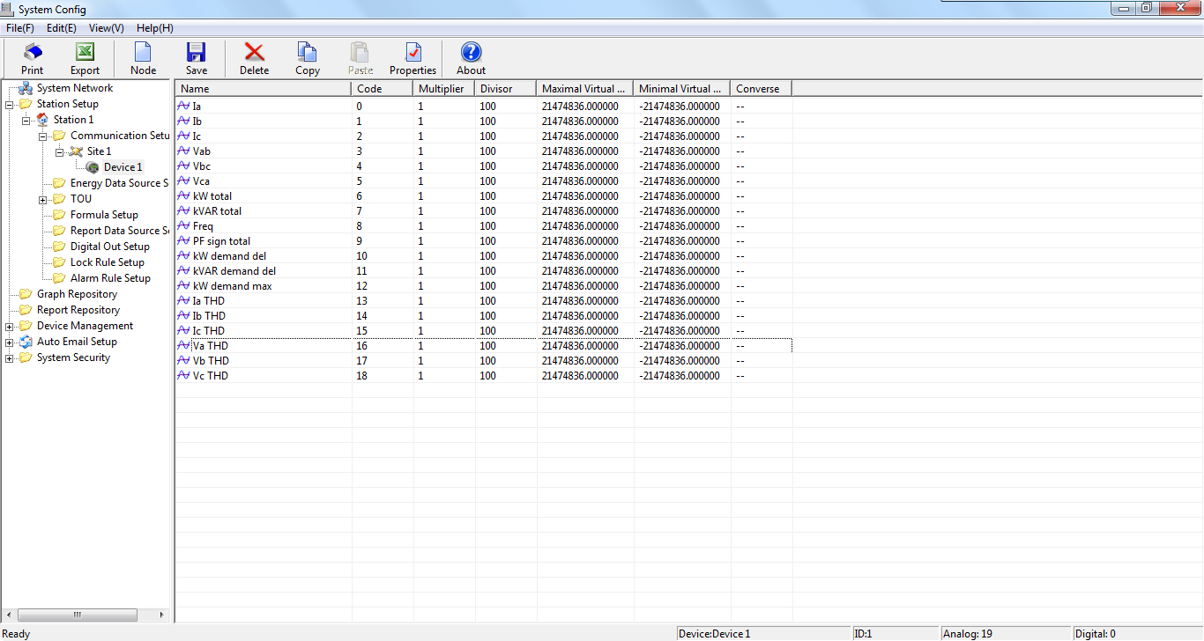
- Right-click on the Device 1 and select Properties. Click Appendix>> from the Device Node Properties window.
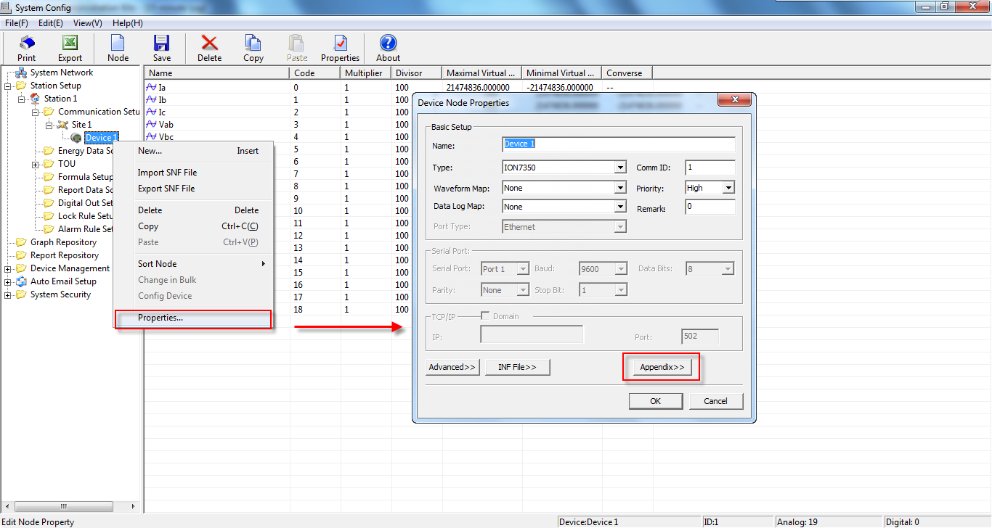
- Edit Modbus Block properties. Click Add a Block>> from the Appendix setup for MODBUS Master Site’s configuration file window, and the Block Edit dialog box appears.
Data Type: Set to Analog In for analog measurements.
Data Format: Set to NUM_S32INT for signed 32-bit integer.
NUM_U16INT: unsigned 16-bit integer.
NUM_S16INT: signed 16-bit integer.
NUM_U32INT: unsigned 32-bit integer.
NUM_S32INT: signed 32-bit integer.
NUM_U32MFP: unsigned 32-bit float.
NUM_S32MFP: signed 32-bit float.
Code: Enter 3 (the function code 3 is read registers)
Start Address: Enter 40011. Set Start Address according to the device’s Modbus mapping.
Source No.: Enter 19. It’s the number of parameters with the same data format.
Start Code: Enter 0. Set Start Code according to the Code column in step 8.
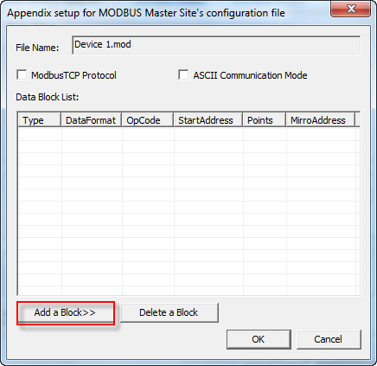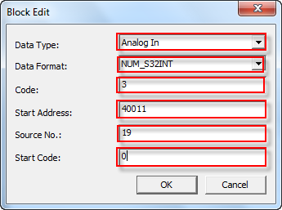
Click OK from the Block Edit window. The Modbus block added is listed in the Data Block List area.
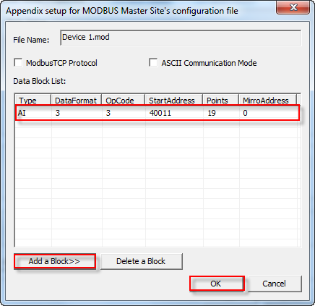
Click Add a Block>> to add other Modbus block.
After all Modbus blocks are added, click OK from the Appendix setup for MODBUS Master Site’s configuration file window.
Click Ok from the Device Node Properties window.
- Save to database. Click Save from the tool bar. Exit PecConfig.
- Start PecSCADA. Check the readings with the device.
